Kindly FBL to generate P7B file for renew SSL CERT: -
https://request.certs.7-11.com/Aperture/

1-login with username and password.
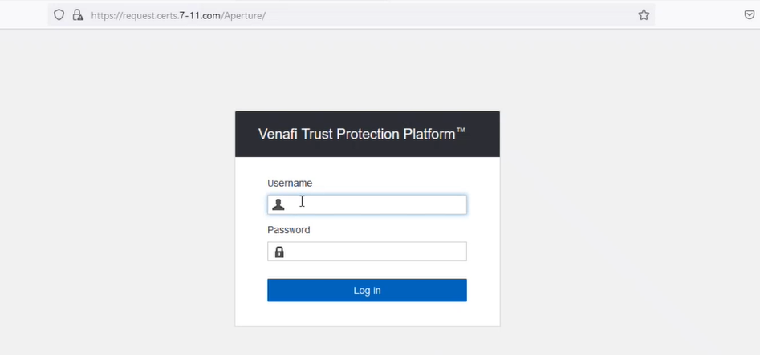

2- click on inventory -> certificate ->click on Create a new certificate
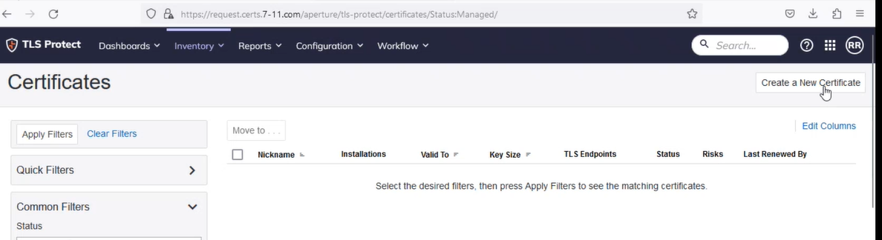

3-Go in the Policy\Certificates\Teams\Ven-DDE-DevOps\Private Server TLS Certificates folder {Internal}
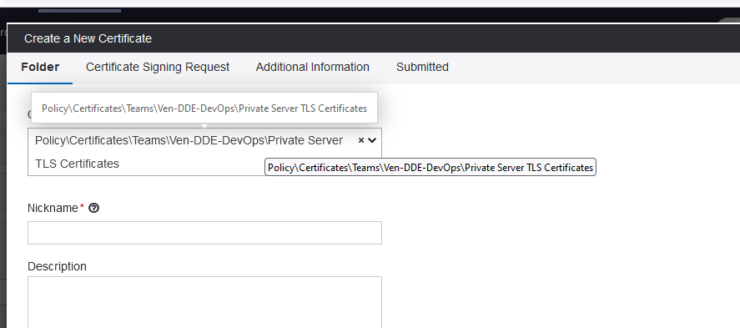

OR
Go In the Policy\Certificates\Teams\Ven-DDE-DevOps\public Server TLS Certificates folder {External}
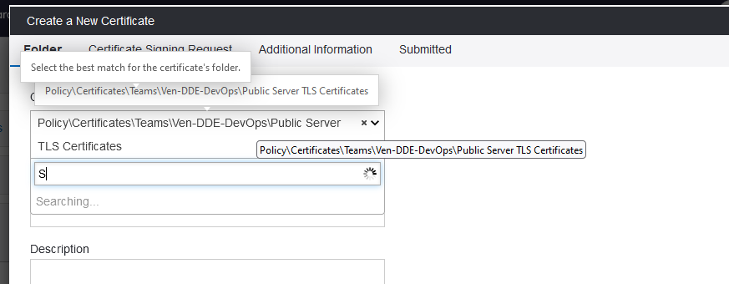

5-Give the Nickname as a Domain name:-
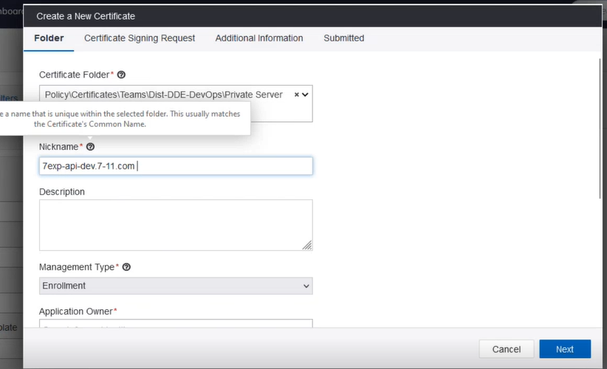

6-choose the director contact: -
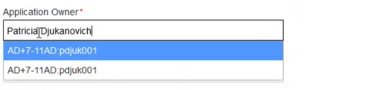

7-choose the certificate type (internal or external) ->cost center =0000 -->Environment (test or prod) -->
Renewal Contact=local: Ven DDE DevOps and click on next

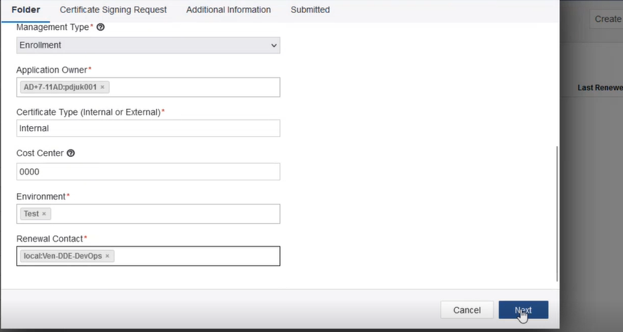

8-CSR Generation (copy your CSR and paste) --> common name as Domain name and click on next
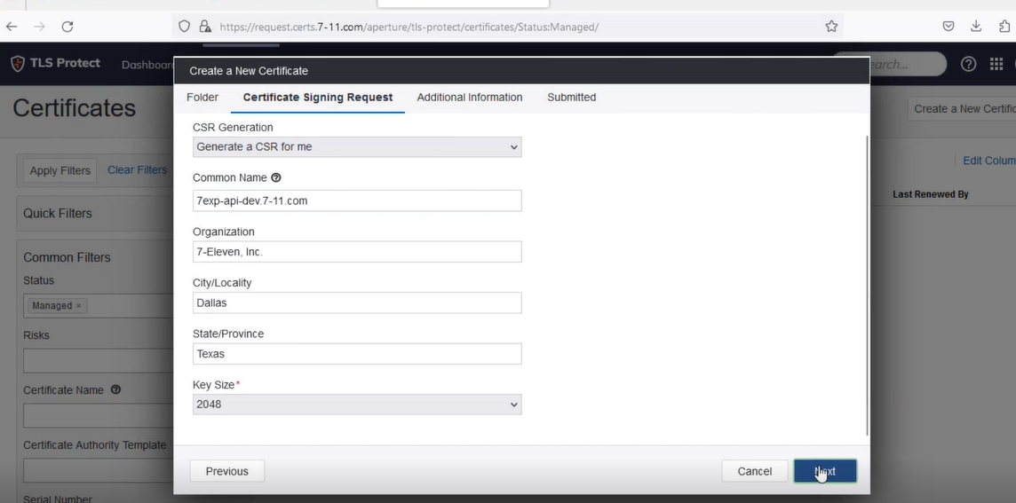

9-select certificate Authority and create certificate and then click on next.

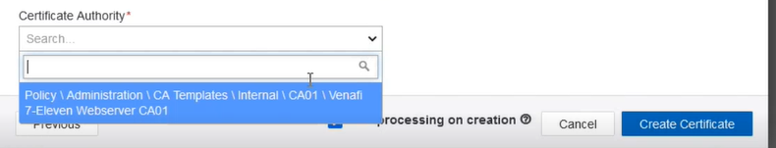

10-click on corner action-->Download the CSR.

